## OUTPUT

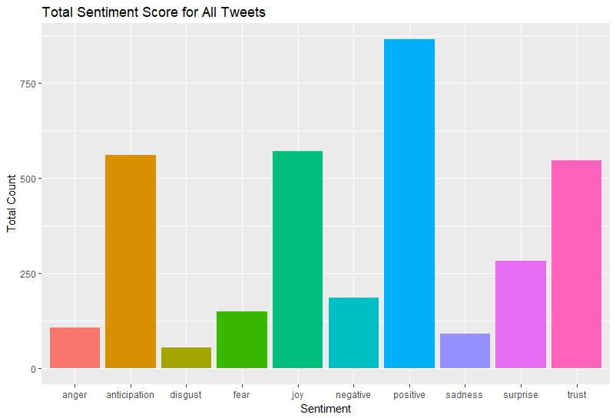

Fig 4.1 Total Sentiment Score of all Tweets

This bar graph shows the sentiment score of **Virat kohli’s** Tweets. It describes the percentage of emotion expressed in his tweets. From the graph it is seen that most of his tweets are positive and there are very less number of tweets which express sadness and moderate would be trust and anticipation

## Fig 4.2 Tweets by sentiment score

The score in the graph shows that the maximum tweets that Virat Kohli tweeted are positive

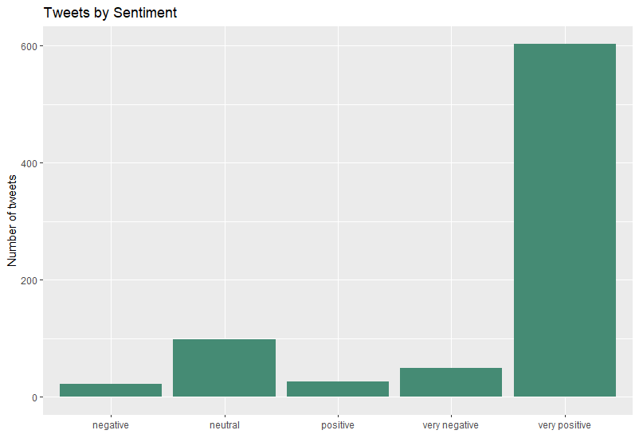Fig 4.3 Tweets By Sentiment

The above graph shows the percentage of positive tweets is high and the perecentage of the tweets which are negative is very low and the moderate one is neutral.

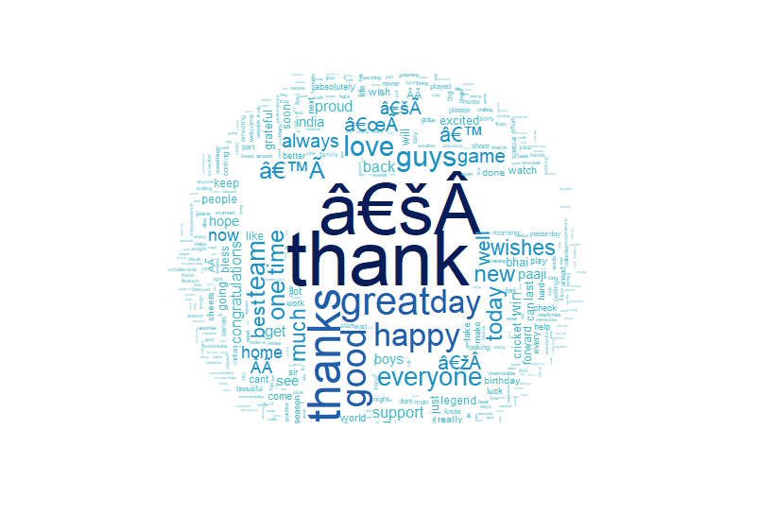

## Fig 4.4 Word cloud

The word cloud represents the words which are used frequently and “thanks” is the word which appeared maximum number of times in **Virat Kohli’s** tweets and hence its size is greater compared to the other words. Here the size of the word represents its frequency